## NEW A… Dis-Eur-Czech Republic-Těšetice-Kyjovice-Sutnách-Figurine**-**Venus**-**4,600 BCE-4,400 BCE

­­ 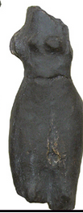

## Fig. 1. Czech Republic-Těšetice-Kyjovice-Sutnách-Figurine**-**Venus**-**4,600 BCE-4,400 BCE

## **Formal Label:** Czech Republic-Těšetice-Kyjovice-Sutnách-Figurine**-**Venus**-**4,600 BCE-4,400 BCE

**Display Description: The Sutnach site at** Těšetice-Kyjovice is located on the southern slope above the Rriver Únanovkou. It was discovered in 1956 and excavated since 1967. It lies about 9 km northeast of Znojmo on the border of the municipalities of Kyjovice and Těšetice. This figurine has been sculpted in two volumes. The portion above the waist is apparently slender while the portion below the waist is more corpulent. This is a feature of many Sutnach female figurines. This particular figurine was fractured in antiquity: It has lostits head, both arms and legs below the knee. Fracturing ritual figurines inside a habitation was common when the houses were ritually burned and the household was moved and figurines inside were ritually broken.

**Accession Number: A152**

#### ****LC Classification:**** GN776.22.C95

**Date or Time Horizon:** 4,600 BCE-4,400 BC

**Geographical Area:** Czech Republic-Těšetice-Kyjovice

**Map, GPS Coordinates:** 48.89567 16.13701, 40° 26' 46" N 79° 58' 56" W

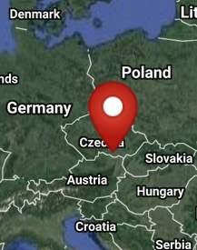 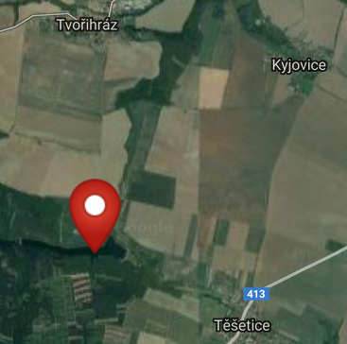

Fig. 2-3. Map of location of Sutnach site at Těšetice-Kyjovice from http://latitude.to/img/latitude-logo.svg.

**Cultural Affiliation:** Neolithic

**Medium:** ceramic.

**Dimensions: H** 5.35 in **Weight:**

**Provenance:**

**Condition: museum replica in resin.**

**Discussion:** TheSutnách site at Těšetice-Kyjovice was discovered by Prof. F. Kalousek 1956 during relief operations "Vinohrady" at Tesetice. Its location is situated between Těšetice and Kyjovice villages on a loess hill near Těšetičky / Únanovky Creek. Moravian painted pottery and stone tools, including obsidian were discovered in addition to Venus ceramic figurines. Since only agricultural work was carried out in the area, it can be assumed that the site and its archaeological objects are in good condition. The first systematic work was carried out in 1964, when it was found that the site is very large (about 12 ha) and bears traces of the Neolithic period, the Bronze Age and Hallstatt.

**References:**

Department of Archaeology and Museology. 2014. The history of research on "Sutnách" at Těšetice-Kyjovice [online]. Brno.

# Pavlů, Ivan and M. Zápotocká. 1978. *Analysis of the Czech Neolithic pottery: morphological and chronological structure of projections* [přel. H. Tichá; tabule kresby, Z. Kříž, T. Mazálková]. Prague: [Academia].